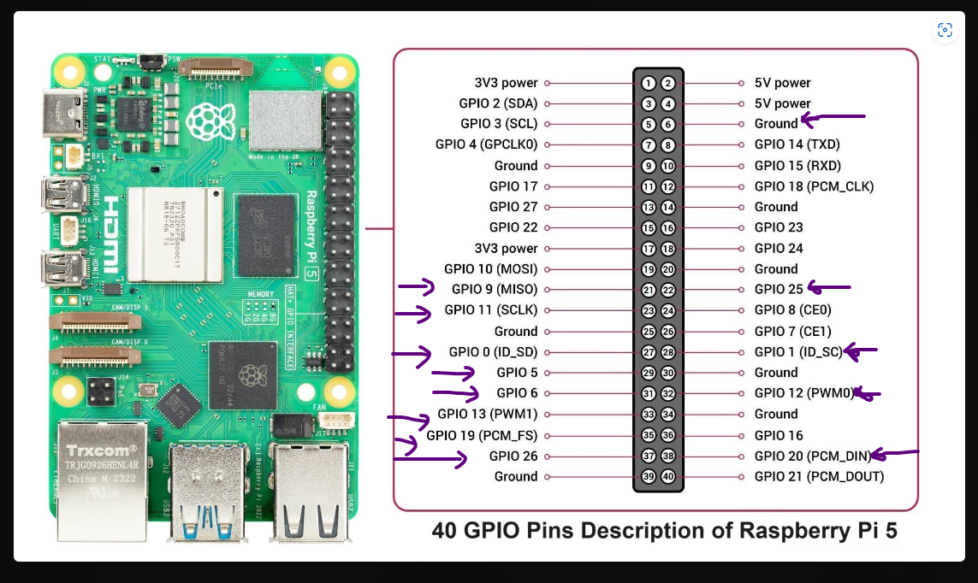

**Pins to connect L298N and Raspberry Pi 5**

| Motor | GPIO for Forward | GPIO for Backward | Enable GPIO | Description |
| --- | --- | --- | --- | --- |
| Front Left | GPIO9 | GPIO11 | GPIO25 | Green, red, skin |
| Front Right | GPIO0 | GPIO5 | GPIO1 | Green, blue, purple |
| Back Left | GPIO19 | GPIO26 | GPIO20 | Yellow, blue, purple |
| Back Right | GPIO6 | GPIO13 | GPIO12 | red, orange, grey |

Ground: PIN 6